# Experiments for 3 Magnets with Different Angle

1. θ = 0

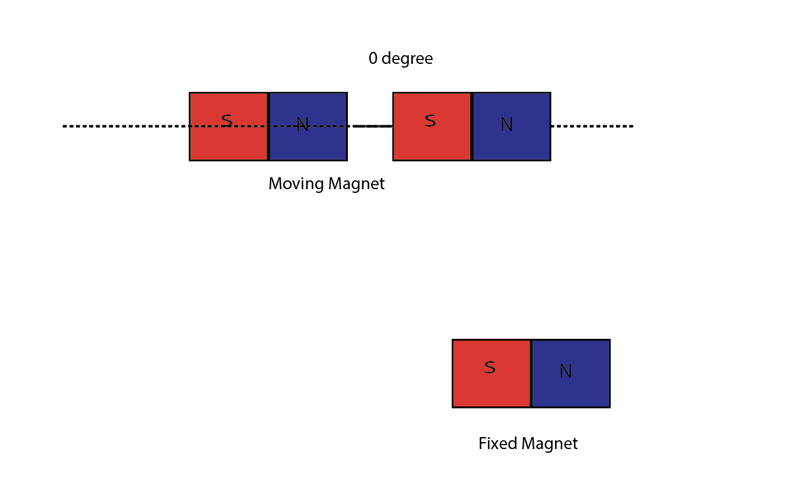

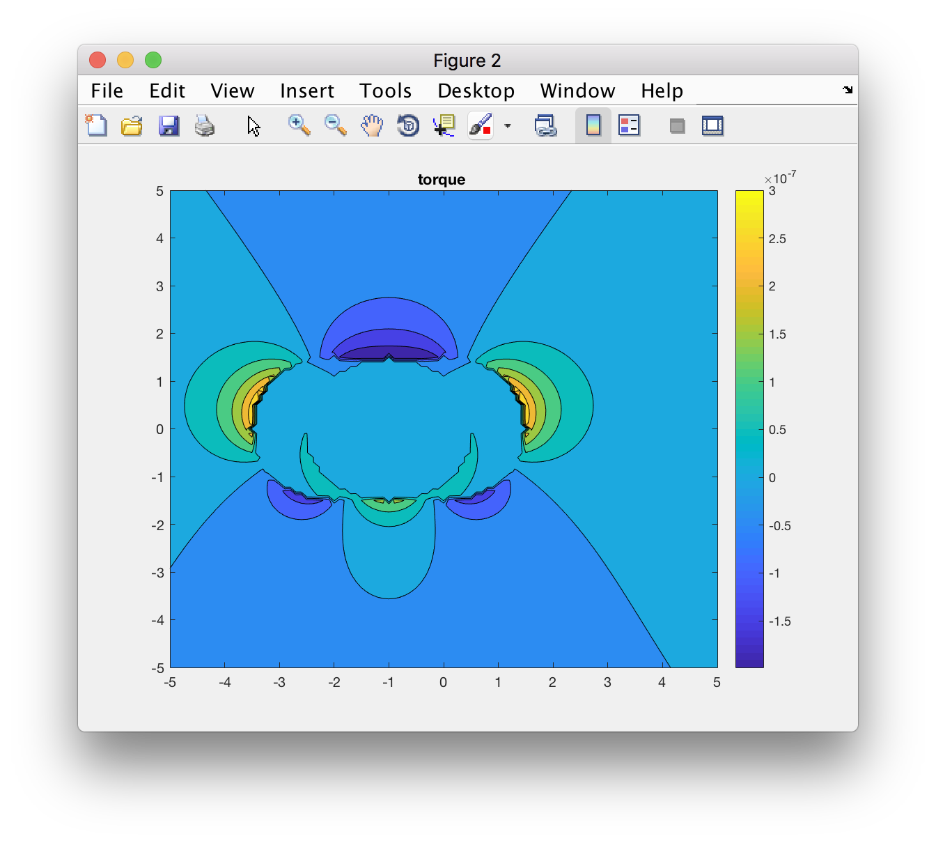

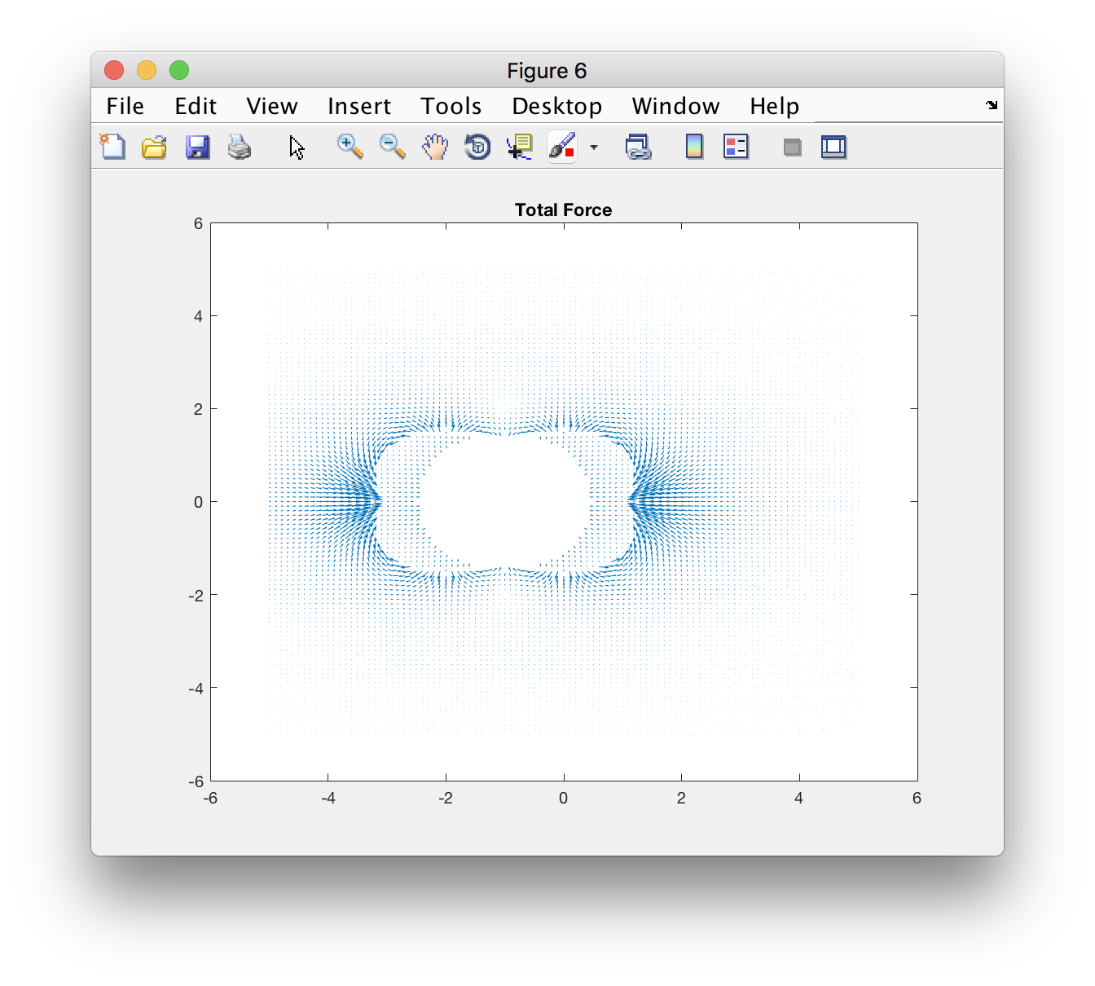

Point(0, 5)

FX = 0

FY != 0 direction: pointing down

Torque = 0

Point (-5, 0)

FX != 0 direction: pointing to the right

FY = 0

Torque = 0

Point (-2, -2)

FX != 0

FY != 0

Net force points towards (0,0)

Torque negative

Point(2,-2)

FX != 0

FY != 0

Net force points towards to the centre

Torque positive

Point (2, 2)

FX != 0

FY != 0

Net force points towards to the centre

Torque negative

Point (-2, 2)

FX != 0

FY != 0

Net force points towards to the centre

Torque positive

1. θ _2= 45 θ _3= 135

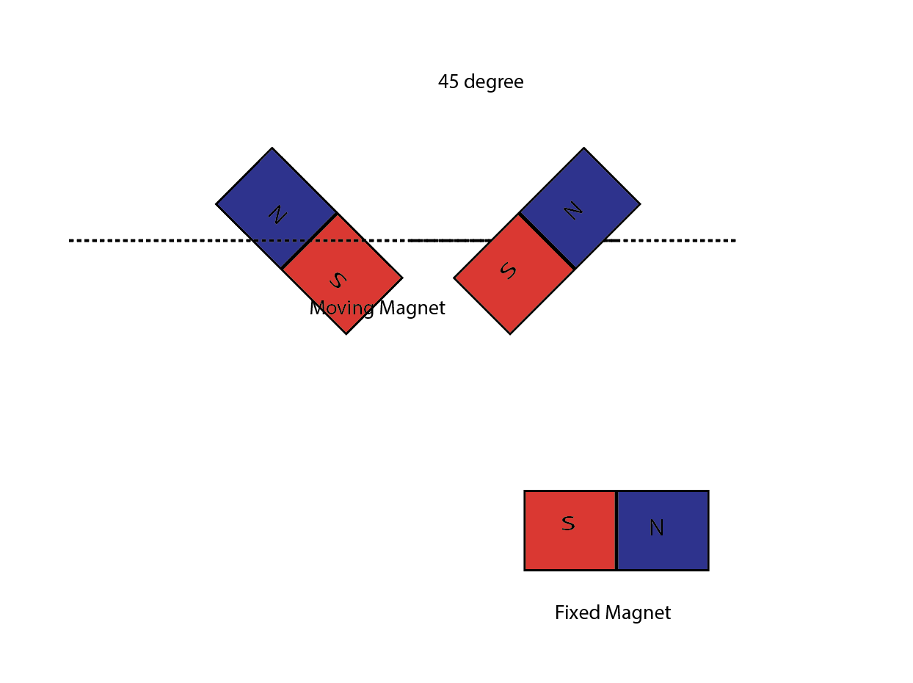

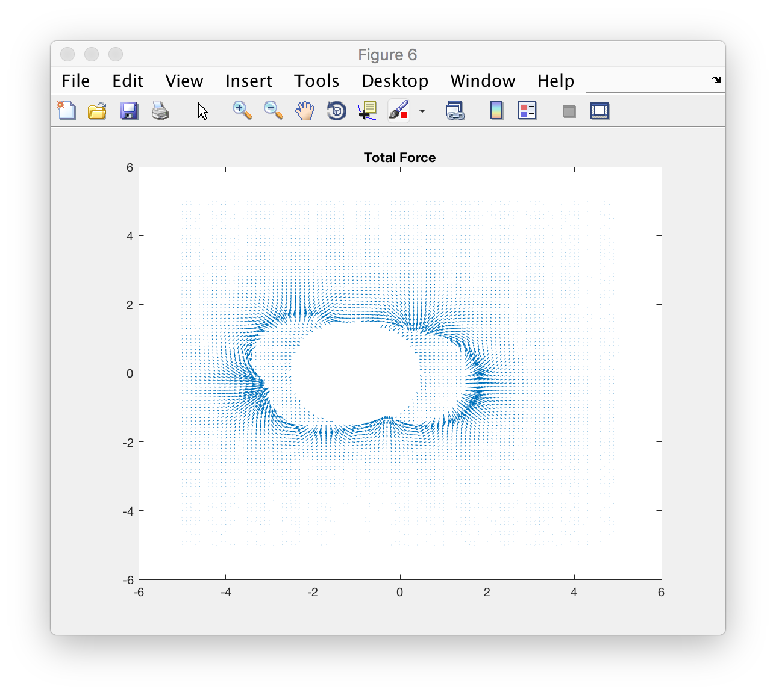

Point (-5,0)

FX != 0

direction: pointing to the right

FY = 0

Torque near zero

Point (5,0)

FX != 0 direction: pointing to the right

FY = 0

Torque near zero

Point (-2, -2)

FX != 0

FY != 0

Net force points opposite to the centre

Torque negative

Point (2, -2)

FX != 0

FY != 0

Net force points opposite to the centre

Torque negative

Point (2,2)

FX != 0

FY != 0

Net force points towards to the centre

Torque positive

Point(-2,2)

FX != 0

FY != 0

Net force points opposite to the centre

Torque negative